**RESEARCH ON IDENTIFICATION OF SUITABLE SITES FOR ORGANIC FARMING IN AINAMOI SUB-COUNTY, KERICHO COUNTY USING AHP AND GIS TECHNOLOGIES.**

1. ***INTRODUCTION***

Ainamoi Sub-County, nestled within the lush landscapes of Kericho County in Kenya, is a pivotal agricultural region renowned for its rich soil, favorable climate, and strategic geographical location. Situated in the southwestern part of Kenya, Ainamoi Sub-County is characterized by rolling hills, fertile valleys, and abundant water resources, making it an ideal environment for agricultural activities, necessary for the conservation and protection of natural treasures with economic improvement of the local villagers.

However, Ainamoi Sub-County has encountered various challenges that have impacted its socio-economic development and agricultural productivity in the recent past.

Climate Change: Ainamoi Sub-County, like many other regions globally, has experienced the effects of climate change, including unpredictable weather patterns, erratic rainfall, and prolonged droughts. These climatic variations have disrupted agricultural cycles, reducing crop yields.

Land Degradation: Intensive agricultural practices, deforestation, and improper land management have contributed to soil erosion and degradation in Ainamoi Sub-County. Soil erosion reduces soil fertility, diminishes crop productivity, and poses long-term sustainability challenges for agriculture in the region. These challenges have caused people from the hilly areas to migrate to other areas due to unemployment.

Organic farming can play a fundamental role for socioeconomic development and to make villages self-sustainable. Organic farming has a great scope in Anemoi because of its climatic and environmental conditions. Avoidance of the external inputs such as synthetic fertilizers and pesticides make it environmentally friendly. Organic Farming also lowers the nitrogen losses from soil and enhances soil carbon sequestration. To get maximum production suitable land, local environmental and geological conditions are prime necessity. Identification of suitable sites for organic farming requires consideration of different climatic conditions, topographical environment and geophysical limitations. Therefore, recent land use land cover data was considered. This report presents a suitability analysis for organic farming in Ainamoi Sub-County, employing the Analytical Hierarchy Process (AHP) and Geographic Information System (GIS) methodologies.

1. ***OBJECTIVES***

* To identify suitable areas for organic farming in Ainamoi Sub-County.
* To prioritize factors influencing the suitability of land for organic farming.
* To utilize AHP and GIS techniques for spatial analysis and decision-making.

1. ***STUDY AREA***

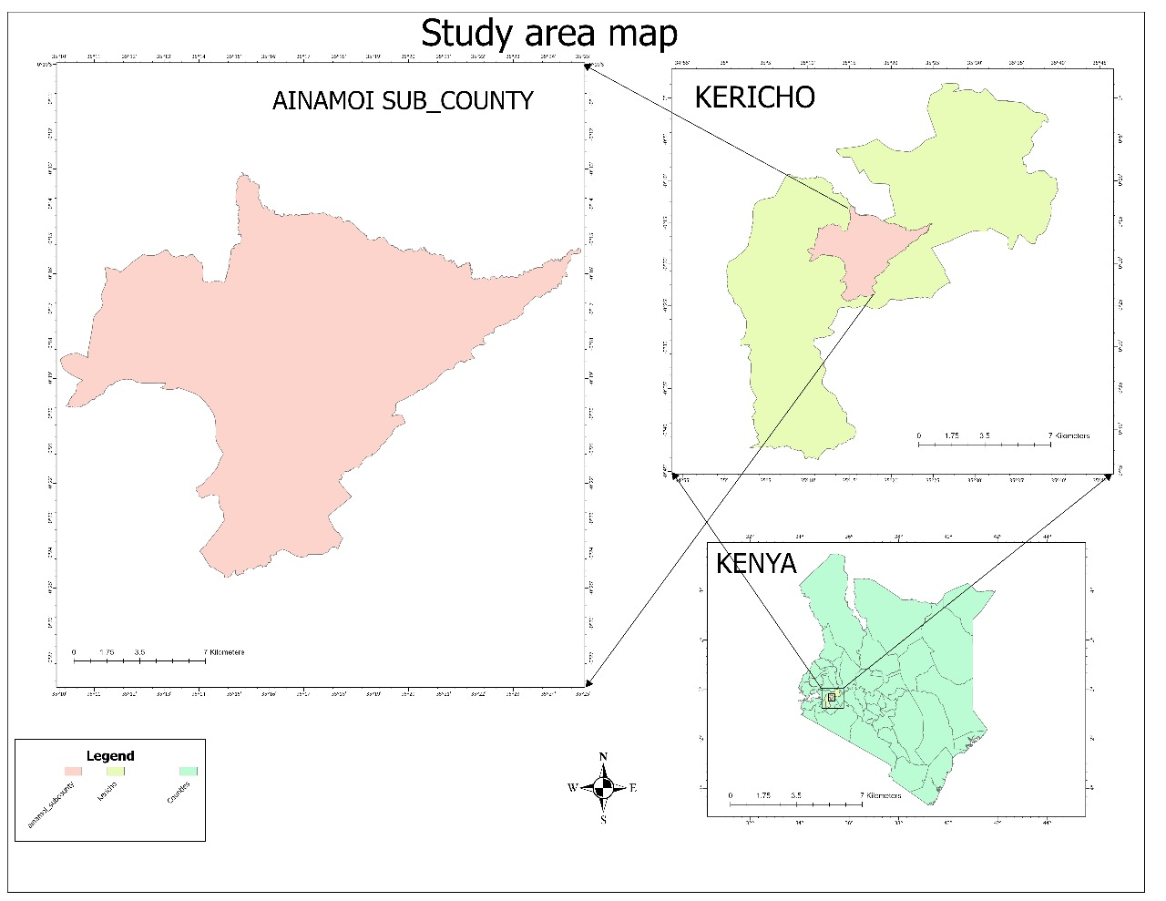

***Figure 1. The study area***

The study area was from Kericho county. According to the County Governments Act of 2012, Kericho county is divided into six sub-counties. Ainamoi was taken as the study area shown in Fig. 1. The area lies between latitude 0° 18' south and longitude 35° 18' east and the elevation of the study area is estimated to be 2098m. It is suited nearby to the localities of Kapsigario and Poywek.

***Figure 2. Schematic representation of the methodology***

Note; In the schematic representation above, rasterization was only applied on the vector layers.

1. ***METHODOLOGY.***

In this study multi criteria site suitability analysis was done to identify appropriate locations for organic farming based on a group of criteria and constraints. Based on there importance and significance in the organic farming, five different criteria and constraints were chosen. The selection of different criteria was based on maximum limitation methods that affects the product yield of organic farming which includes soil type, slope, drainage, and accessibility of transport network(roads). Weights for each criterion were calculated using AHP and after that weighted overlay was done to generate the suitability map.

1. ***SOFTWARES AND DATA USED.***

The softwares used for this study were: Quantum GIS 3.36 used for clipping the area of study (Ainomai), Arc map for creation of the study area map and ArcGIS pro for generation of criteria map and suitability model.

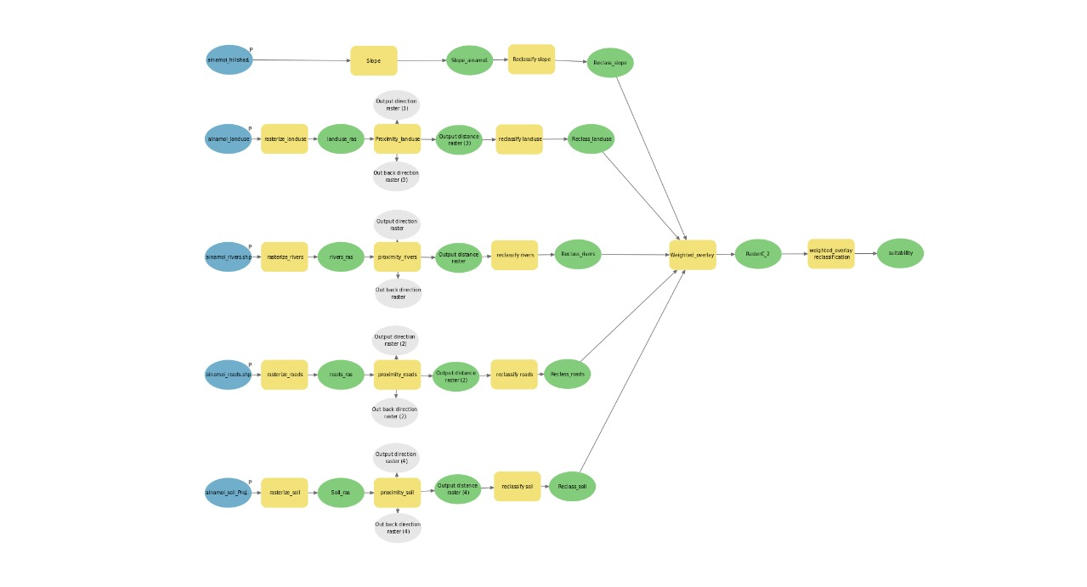

***Figure 3. Site suitability model for organic farming.***

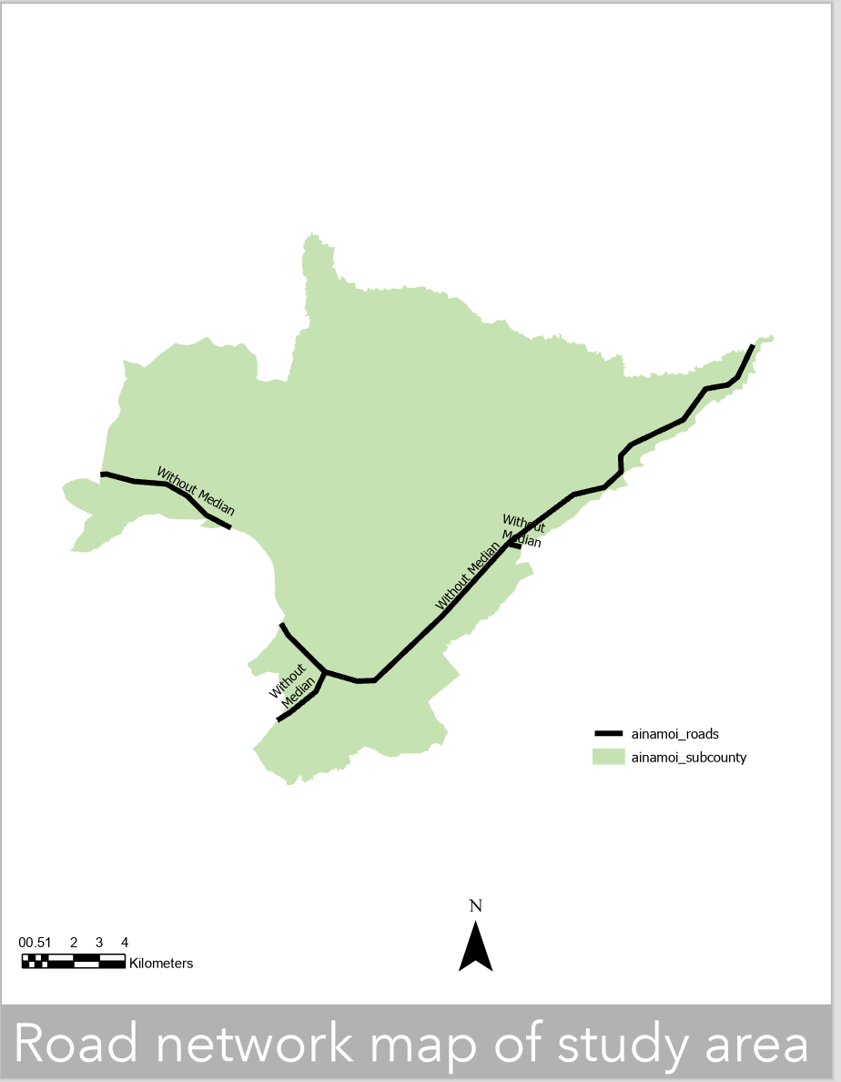

***Figure 4. Road map of study area***

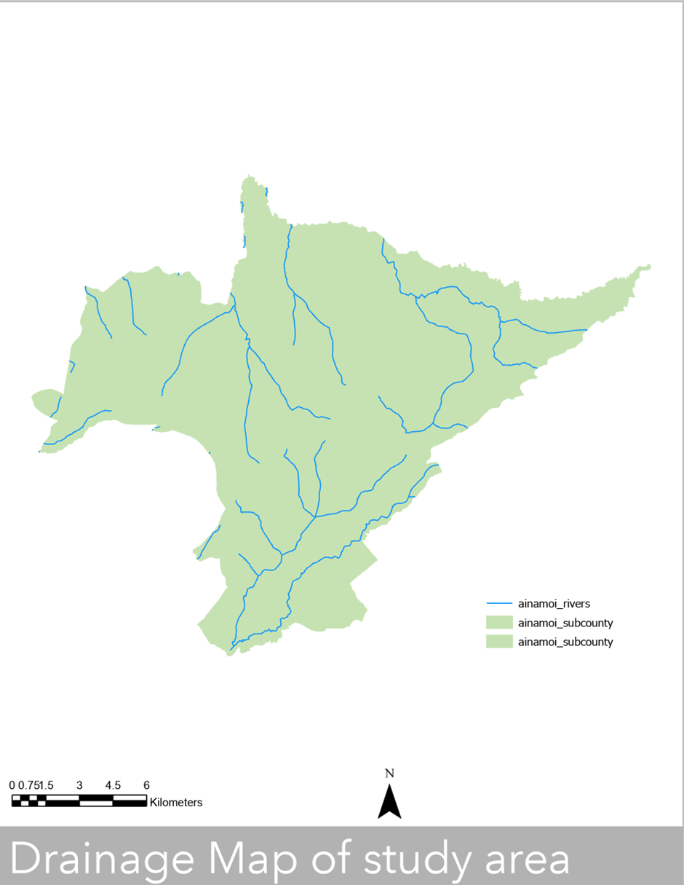

***Figure 5. Drainage map of study area.***

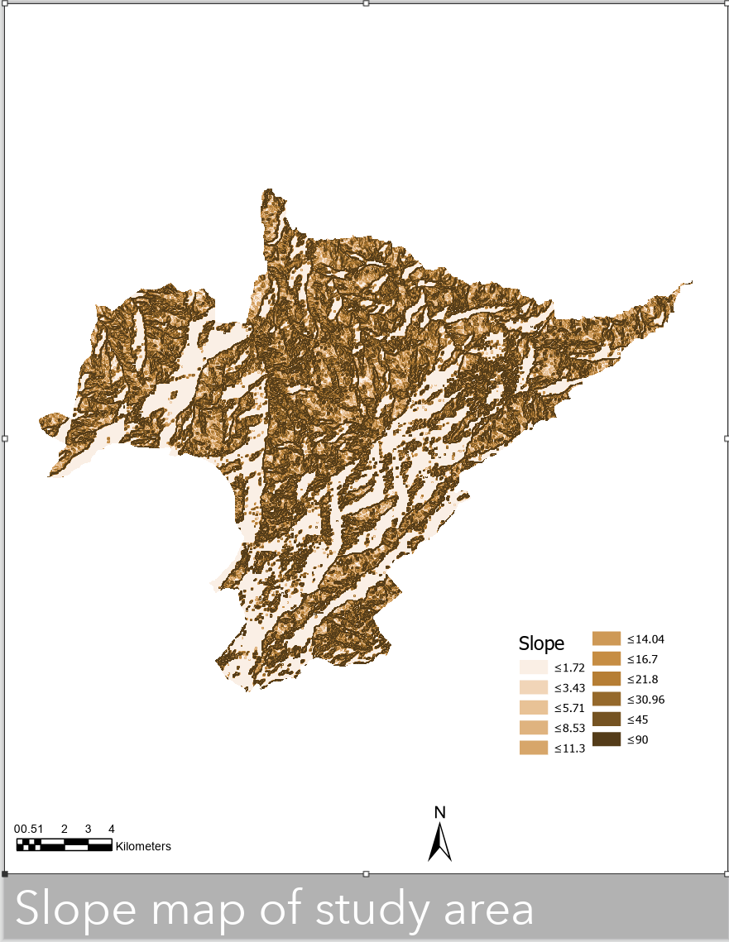

***Figure 6. slope map of the study area.***

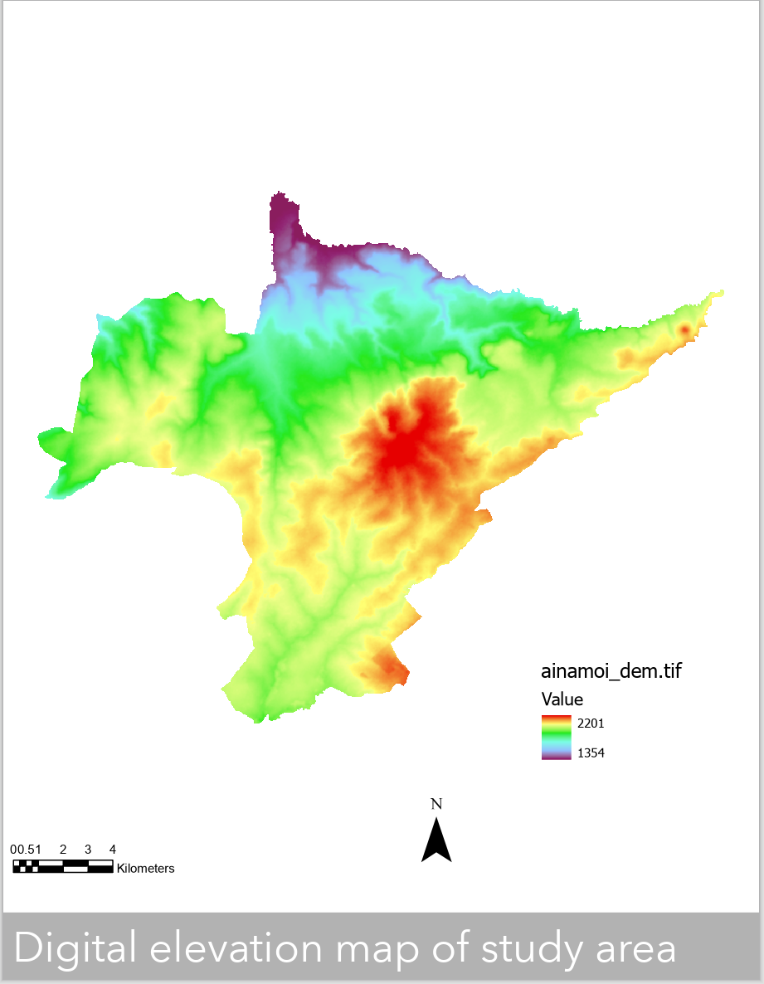

***Figure 7. Digital elevation map of study area***

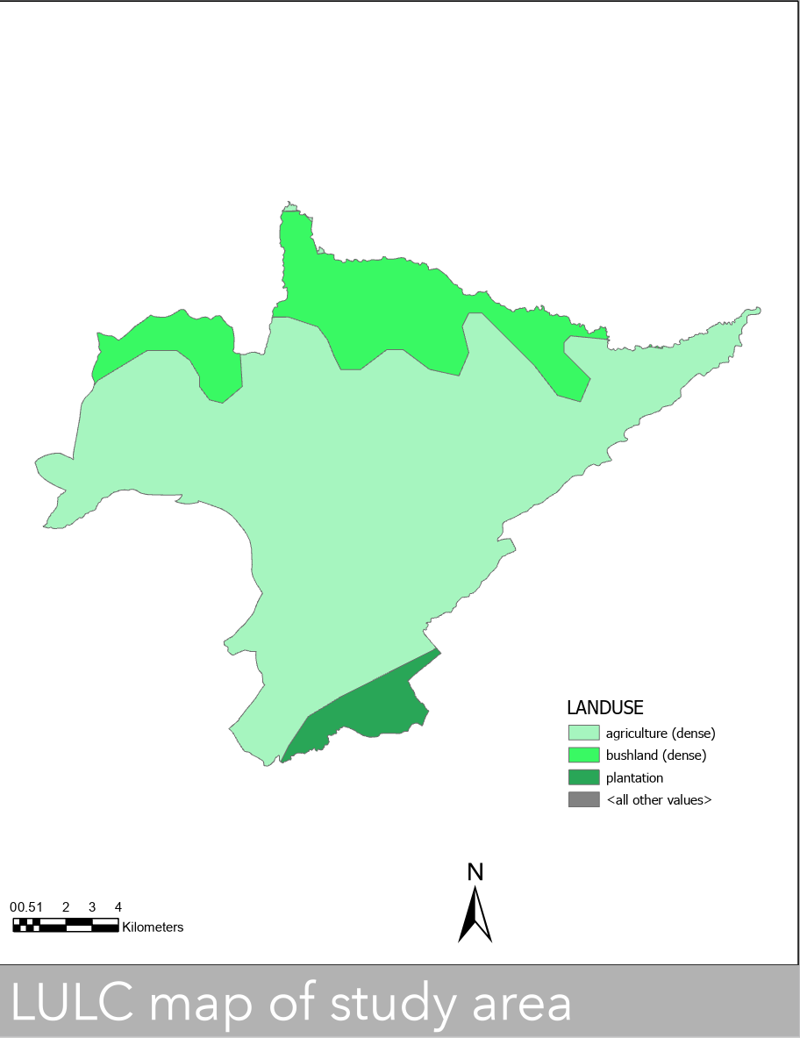

***Figure 8. LULC map of the study area***

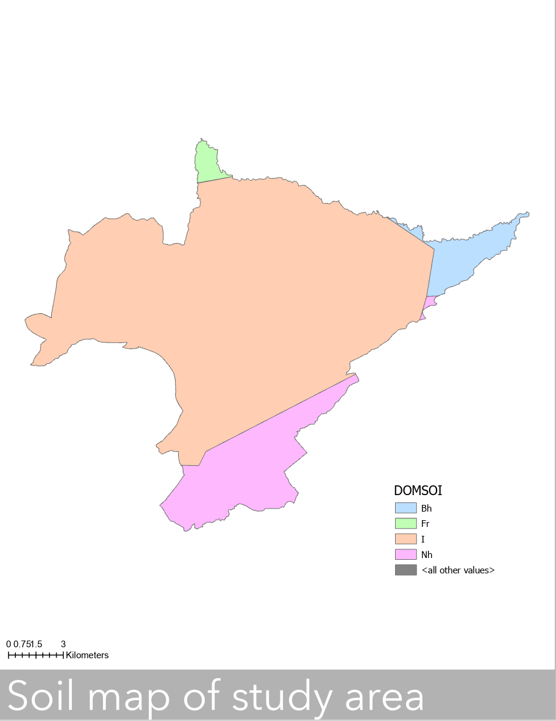

***Figure 9. soil map of study area.***

1. ***RESULTS AND DISCUSSIONS***

The transportation of the raw product requires a well-connected network of roads. So, the land nearest to the roads was given more importance and the road map is shown in Fig. 4. The drainage network is shown in Fig. 5. Digital elevation map was generated to show the height variation of the study area as shown in Fig. 7. The slope is also an important parameter in the preset study area; the land with the gentle slopes were taken as the most suitable and have been given highest importance as shown in Fig. 6. The soil type of the area is equally important for the organic farming. The young alluvial soil found the “I” horizon was found to be the most suitable for the organic farming because it has clay and has the capacity to retain more water as shown in the Fig. 9. The rich soil is given much importance for organic farming because it is most suitable for farming as its capacity to retain much water and moisture is high. In the Fig. 8 above indicates the Land use Land cover map that was used to determine the available suitable land for organic farming.

The final site suitability map generated after weighted overlay for organic farming was divided into five classes, that is, most suitable areas, more suitable areas, suitable areas, less suitable areas and not suitable areas. The AHP give the most suitable areas which are most adequate with respect to the parameters considered as shown in the Fig. 10 below. The dark green patches represent the most suitable area for the organic farming while reddish patches represent the areas that are totally not suitable for organic ***farming.***

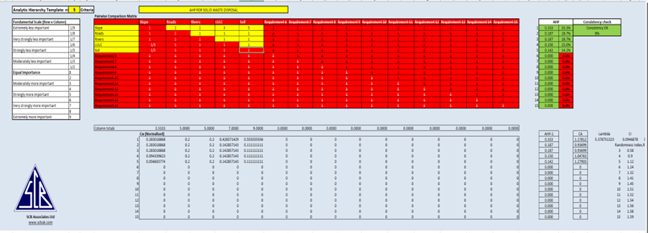

***Figure. 10. The AHP table with a consistency check of 8%***

1. ***About AHP table;***

AHP table provides a structured framework for evaluating and prioritizing criteria relevant to organic farming suitability, it was used to systematically assess potential farming locations and make informed decisions to promote sustainable organic farming practices. Below is how it was used:

Top of Form

Bottom of Form

• **Criteria Selection:** The AHP table facilitates the identification and selection of criteria relevant to organic farming suitability, such as soil quality, accessibility of roads, slope, land use land cover, and proximity to water sources (rivers). These criteria were chosen based on their importance in determining the viability and sustainability of organic farming practices.

• **Pairwise Comparisons:** It was used to conduct pairwise comparisons between criteria to determine their relative importance in relation to organic farming suitability. For example, soil quality was compared to proximity to water sources and assession of which criterion had a greater impact on the suitability of a farming location.

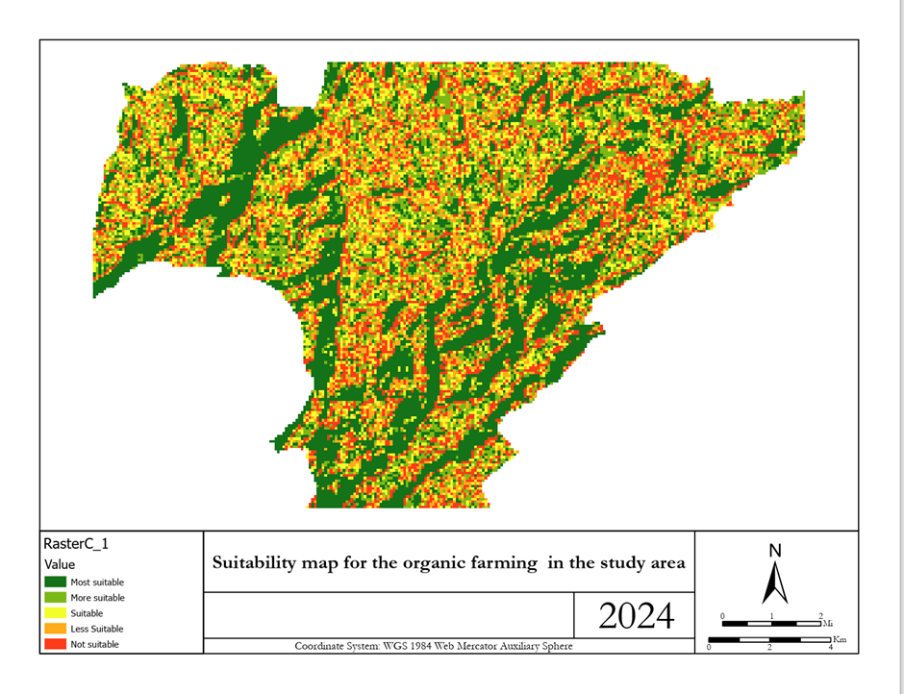***Figure 10. Suitability map for the organic farming in the study area.***

1. ***CHALLENGES.***

These challenges include:

* **Data Availability and Quality:** One of the primary challenges is the availability and quality of data required for AHP and GIS analysis. Obtaining accurate and up-to-date data on soil quality, drainage, land use, and other relevant factors can be challenging, particularly in rural or remote areas like Ainamoi.
* **Integration of Multiple Criteria:** Integrating multiple criteria into the AHP and GIS analysis requires careful consideration of their relative importance and interactions. Balancing the weights of different criteria and ensuring consistency in their evaluation was challenging, due to our difference in perspectives and priorities.
* **Expertise and Capacity:** Conducting AHP and GIS analysis requires specialized expertise in data analysis, spatial modeling, and decision support systems.

1. ***CONCLUSIONS***

The analysis of this study was mainly focused on the identification of the highly suitable land for organic farming in the study area. AHP matrix with integration of GIS is used for the analysis in which five different criteria were considered. The AHP with combination of GIS was found very useful for the suitable site identification. The final result can be adopted for the decision-making process of the organic farming in the study area, as it gives insight in finding the suitable areas. The results can be more refined by critically analyzing the techniques used. The study includes the physical parameters only and need to incorporate the social and economic parameters.

The integration of AHP and GIS techniques has provided valuable insights into identifying suitable locations for organic farming in Ainamoi Subcounty, Kericho County. By considering multiple criteria and spatial analysis, this study offers a comprehensive approach to support decision-making in sustainable agriculture and land use planning.

1. ***RECOMMENDETIONS.***

Engage stakeholders, including farmers, agricultural experts, and local communities, in defining and prioritizing criteria for organic farming suitability.

Explore advanced remote sensing techniques and high-resolution satellite imagery to improve the spatial resolution of GIS data.

The use of high-resolution satellite data will aid in analyzing more finer areas. The identified zones have to be verified on ground level with other local parameters before the final implementation.

1. ***REFFERENCES***
2. Humanitarian data resource for acquiring the shape file data
3. USGS Earth explore for getting the DEM data.